**Project Design Phase-II**

**Technology Stack (Architecture & Stack)**

|  |  |
| --- | --- |
| Date | 16 NOV 2022 |
| Team ID | PNT2022TMID50270 |
| Project Name | Hazardous area monitoring for industrial plant powered by IOT |
| Maximum Marks | 4 Marks |

**Technical Architecture:**

The Deliverable shall include the architectural diagram as below and the information as per the table1 & table 2

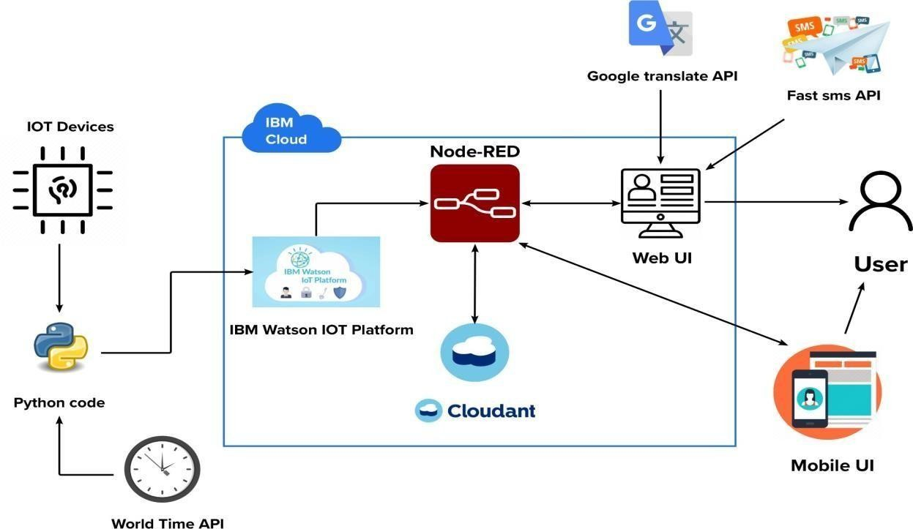

**1 : Components & Technologies:**

|  |  |  |  |
| --- | --- | --- | --- |
| **S.No** | **Component** | **Description** | **Technology** |
| 1. | User Interface | Web UI, Mobile App, SMS service and Wearable devices | Node-RED, Fast sms and MIT App inventor |
| 2. | Application Logic-1 | Getting input from smart beacons | Embedded C and Python |
| 3. | Application Logic-2 | Process data in cloud | IBM Watson IOT platform, Cloudant DB and Node-RED |
| 4. | Application Logic-3 | Display data to the user | Web UI, Fast sms and Mobile application |
| 5. | Database | Real time database | Cloudant DB |
| 6. | Cloud Database | Database Service on Cloud | IBM Cloudant |
| 7. | External API-1 | To send sms to user | Fast sms API |
| 8. | External API-2 | Language for the website is written to be dynamic | Google translate API |
| 9. | External API-3 | To access time | World time API |
| 10. | Smart Beacon | To monitor the area and update the stats in the cloud | NodeMCU and Sensors |
| 11. | Infrastructure (Server / Cloud) | Application Deployment on Cloud | IBM Cloud |

**Table-2: Application Characteristics:**

|  |  |  |  |
| --- | --- | --- | --- |
| **S.No** | **Characteristics** | **Description** | **Technology** |
| 1. | Open-Source Frameworks | The Node-RED open source frameworks are used to build the web application as well as to communicate with the mobile application and to handle alert sms | Node-RED framework |
| 2. | Scalable Architecture | The 3 – tier architecture used with a separate user interface, application tier and data tier makes it easily scalable | IBM Watson Studio |
| 3. | Availability | The web application is highly available as it is deployed in cloud | IBM Cloud |
| 4. | Performance | The performance of the website is improved with caching and security | IBM Cloud Internet Services |